Article 13 — The Control Layer

Michal Doroszewski

The Elevator Panel
You step into an elevator. Stainless steel walls, soft lighting, the quiet hum of machinery. You press the button for the 12th floor. It lights up. The doors close. The car rises smoothly. Then the button goes dark. The elevator stops between floors. A chime sounds. A small screen flashes: “Command rejected. Please reselect.”
You press 12 again. Nothing. You try 11. The button lights, then immediately turns off. You try 10. Same result. The elevator stays still. You tap the “Door Open” button. It flickers, then goes dark. The elevator does not move. The doors do not open. The panel resets itself every few seconds, as if it cannot remember what you asked it to do.
A voice comes over the speaker: “Destination unclear. Please provide valid input.”
You press 12 again. The elevator begins to move — down. You didn’t ask for down. You didn’t ask for anything except “12.” The elevator stops at the lobby. The doors open. The voice says, “Request denied. Please try again.”
People waiting outside step in. They press their floors. The panel lights up, then resets. The elevator refuses every command. The system is not broken. It is confused. It cannot evaluate the requests because it cannot trust the signals that tell it what is allowed.
That is the Control Problem — not the permissions kind, but the architectural kind. The kind that appears when cloud systems cannot reliably evaluate policy, enforce decisions, or maintain consistent authority across boundaries. The kind that turns an elevator into a negotiation.
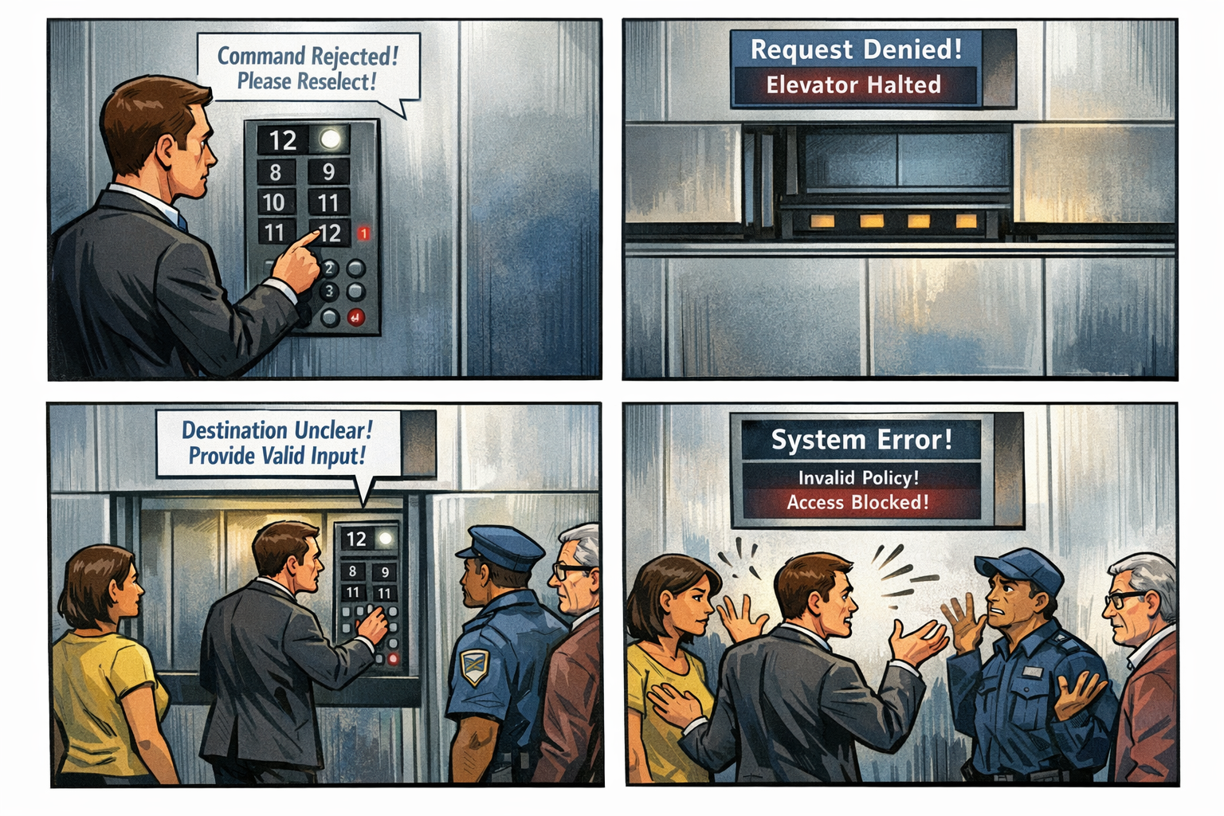

Control Is the Third Layer of Modernization
Visibility shows what is happening. Continuity stabilizes identity across transitions. But control determines what the system is allowed to do. Modern cloud platforms rely on real‑time policy evaluation — decisions based on identity, device posture, location, risk, and context. When those signals are delayed, distorted, or missing, the control plane hesitates, resets, denies, or contradicts itself. A system without control is not insecure. It is unpredictable.

Why GCC‑Moderate Breaks Control
The FedRAMP Moderate boundary was built for static rules, not dynamic evaluation. It assumes fixed locations, fixed devices, fixed trust paths, and fixed policy logic. Modern identity does not work that way. Dynamic control requires real‑time posture, real‑time location, real‑time risk, real‑time refresh, and real‑time policy lookup. But the boundary filters, delays, or blocks the signals that feed the control plane. The system cannot evaluate the request. The elevator panel resets. The architecture does not deny the request because it is wrong. It denies the request because it cannot decide.

Headquarters and Field Offices Experience Control Differently
Headquarters sits close to the control plane. Policy evaluation is fast, posture is current, location signals are accurate, refresh is stable, and decisions are consistent. Field offices sit far from it. WAN optimizers distort timing, inspection layers delay signals, region drift mislabels location, refresh endpoints are distant, and policy evaluation times out. The same user, same device, same request — different result. The architecture creates two control realities, and the system enforces both.

Why Control Failures Are Misdiagnosed
When control collapses, every team blames the part they can see. Security blames the policy. Identity blames the token. Network blames latency. Operations blames the region. Users blame the cloud. Everyone is correct. Everyone is wrong. The failure is architectural. The control plane cannot evaluate the request because the boundary prevents it from receiving the truth. A system cannot enforce what it cannot see. A system cannot decide what it cannot evaluate.

Modernization Stalls Without Control
Without a functioning control layer, conditional access misfires, device trust oscillates, location evaluation drifts, session decisions contradict, enforcement becomes inconsistent, users experience random denials, and teams chase phantom misconfigurations. This is not a governance problem. It is architectural indecision.

The Root of the Control Problem
The control problem is not caused by bad policy, misconfigured rules, incorrect groups, user error, or device drift. It is caused by an architecture that cannot reliably deliver the signals required for dynamic evaluation. The boundary filters the inputs. The WAN distorts timing. The inspection layers delay the truth. The region model mislabels the context. The control plane receives partial information. A system cannot enforce policy with partial truth. A system cannot make decisions inside a fog.

The Only Way Forward
Control must be restored. The boundary must allow policy‑critical signals. Timing must be preserved end‑to‑end. Region awareness must be accurate. Device posture must be current. Risk evaluation must be complete. Policy lookup must be real‑time. Only then can decisions be consistent. Only then can enforcement be predictable. Only then can modernization move forward without contradictions.

About the Author
Michal Doroszewski is a technology strategist focused on cloud architecture, identity platforms, and federal modernization. He writes about the structural and architectural forces that shape government IT, translating complex technical constraints into clear, accessible narratives for leaders and practitioners.

